Business Requirements Document(BRD) Template
Hotel Search and Filtering: From City and Date Entry to Hotel Selection
July 2026
Version 1.01

Company Information

Document Revisions
Date | Version Number | Document Changes
05/02/20xx | 0.1 | Initial Draft

Approvals
Role | Name | Title | Signature | Date

Introduction

Project Summary

Objectives
Primary Goal: Provide users with an efficient search flow—from initial destination/date entry to hotel selection—supported by rich filtering (price, amenities, ratings) and sorting capabilities.
Business Alignment: Enhance user engagement and competitive differentiation by reducing search friction and improving overall customer satisfaction (CSAT) during the discovery phase.

Background
[Provide a brief history of how the project came to be proposed and initiated, including the business issues/problems identified, and expected benefit of implementing the project/developing the product.]

Business Drivers
[List the business drivers that make development of this product important. These can be financial, operational, market or environmental.]

Project Scope
The project covers the delivery of a web-based hotel search and filtering interface, spanning from the initial city and date input form to the final selection of a hotel from the results list or interactive map. It includes integration with real-time hotel availability and multi-criteria sorting and filtering. The project scope is limited to the search phase and does not cover room reservation, payment processing, user account registration, or third-party travel packages.

In Scope Functionality
These are all the features we will build for the search and filter module in this project:
- Search Inputs:
  - Destination search field with auto-complete suggestions.
  - Calendar to pick check-in and check-out dates.
  - Selectors for the number of adults, children, and children's ages.
- Search Results Display:
  - List of hotel cards showing the main photo, review score, and distance to the city center.
  - Total price calculation for the entire stay (not just one night).
  - Urgency and marketing tags (like "1 room left" or "Best price").
- Sorting and Filtering:
  - Default sorting by "Recommended" hotels.
  - Sorting by price, rating, or popularity.
  - Price range filter using a slider.
  - Filters for review scores (e.g., 8+ rating), free cancellation, and specific amenities (Wi-Fi, parking, breakfast).
- Map Features:
  - Button to switch between List view and Map view.
  - Interactive map showing pins with hotel prices.
- System and Integrations:
  - Real-time connection to show actual hotel availability and prices.
  - Tracking system to log searches that give zero results.
  - Support for multiple currencies and languages.
  - Responsive web design to work well on mobile phones and desktop computers.

Out of Scope Functionality
Other Property Types & Services
- Searching for private apartments, flights, car rentals, or tour packages (we only search for regular hotels).
Booking Process
- Selecting a specific room type (our project ends when the user clicks on a hotel).
- The booking checkout process and reservation confirmation.
Payments & Finance:
- Processing any payments or adding bank card details.
- Using promo codes, discounts, or loyalty program points.
User Accounts:
- Creating an account, logging in, or managing a user profile.
- Viewing booking history, managing, or cancelling previous bookings.
Reviews & Communication:
- Writing, rating, or editing hotel reviews (we only show existing ratings).
- Direct messaging or chatting with the hotel reception.

System Perspective
[Provide a complete description of the factors that could prevent successful implementation or accelerate the projects, particularly factors related to legal and regulatory compliance, existing technical or operational limitations in the environment, and budget/resource constraints.]

Assumptions

Constraints

Risks

- .

Issues

Business Process Overview
[Describe how the current process(es) work, including the interactions between systems and various business units. Include visual process flow diagrams to further illustrate the processes the new product will replace or enhance.
Use case documentation and accompanying activity or process flow diagrams can be used to create the description(s) of the proposed or “To-Be” processes.]

Current Business Process (As-Is)
At any point during or after deployment of web apps or web sites (internal or external) to support business activities, development/support teams may create and deploy widgets.
- CMS / database administrators for the employee portal use the CMS tool to create widgets. They can test widgets in the designated staging environment, then register them and deploy to production.
- Development teams may deploy widgets to development and testing environments set up for their development projects. They must check widget code into and out of the source code repository according to their projects’ development schedule.
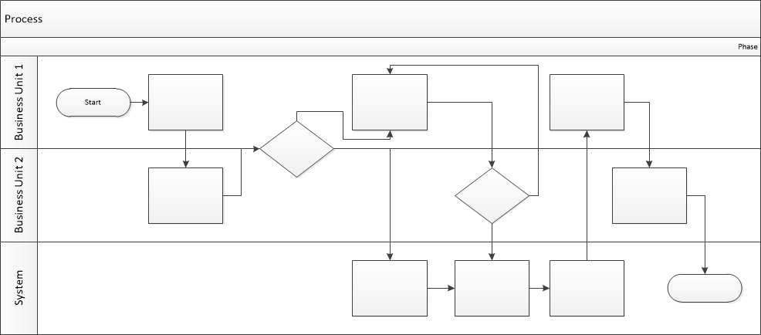

Proposed Business Process (To-Be)
- Technical Lead searches repository
- If widget is not found, user creates a new widget name record.
- WINS validates that all fields have been completed.
- WINS confirms that no similar widgets exist
- User confirms record to be created.

- User searches repository to locate existing widget description.
- WINS displays record
- User selects Edit to open and modify record
- WINS validates all fields completed correctly
- User confirms changes.
- WINS confirms changes and updates Audit table.


Stakeholder Requirements

User (Traveler) Requirements
- SR‑01: Hotel Search — The traveler needs to search for hotels in a selected city.
- SR‑02: City Autocomplete — The traveler needs city suggestions while typing to speed up the search process.
- SR‑03: Date Selection — The traveler needs to select check‑in and check‑out dates using an interactive calendar.
- SR‑04: Guest Configuration — The traveler needs to specify the number of adults and children, including children’s ages.
- SR‑05: View Search Results — The traveler needs to view a list of available hotels with the total stay price clearly displayed.
- SR‑06: Apply Filters — The traveler needs to filter hotels by price, rating, amenities, property type, and other relevant criteria.
- SR‑07: Map View — The traveler needs to view hotels on an interactive map to understand their location.
- SR‑08: Hotel Details — The traveler needs access to detailed hotel information, including photos, descriptions, policies, reviews, and booking conditions.
- SR‑09: Transparent Pricing — The traveler needs to see the final price without hidden fees or unexpected charges.
- SR‑10: Fast Booking — The traveler needs a simple and efficient booking flow with minimal steps.

Business Owner Requirements
- SR‑11: Hotel Prioritization — The business owner needs high‑margin and revenue‑generating hotels to appear higher in search results.
- SR‑12: Smart Sorting — The business owner needs a sorting algorithm that increases conversion and overall revenue.
- SR‑13: Marketing Tags — The business owner needs persuasive marketing labels (e.g., “Only 1 room left”, “Best Price”) to improve booking performance.
- SR‑14: Analytics & Insights — The business owner needs access to analytics on searches, clicks, and bookings to support decision‑making.
- SR‑15: Inventory & Pricing Control — The business owner needs real‑time control over room availability and pricing.
The requirements in this document are prioritized as follows:
Value | Rating | Description
1 | Critical | This requirement is critical to the success of the project. The project will not be possible without this requirement.
2 | High | This requirement is high priority, but the project can be implemented at a bare minimum without this requirement.
3 | Medium | This requirement is somewhat important, as it provides some value but the project can proceed without it.
4 | Low | This is a low priority requirement, or a “nice to have” feature, if time and cost allow it.
5 | Future | This requirement is out of scope for this project, and has been included here for a possible future release.

Functional Requirements
Req# | Priority | Description | Rationale | Use Case Reference | Impacted Stakeholders
General / Base Functionality
FR-G-001 | 1 | Search Input Parameters  The system shall capture search inputs: destination city (with autocomplete), check-in/out dates, adults count, and exact ages of children | Ensures accurate room occupancy matching and correct dynamic price calculation based on child age policies. |  | End Travelers / Guests
FR-G-002 | 1 | Search Results Generation & Display  The system shall process user search criteria and display a list of available hotels that match the destination, dates, and guest capacity. | Allows users to see all available accommodation options immediately after submitting their search request. |  | End Travelers / Guests
FR-G-003 | 2 | Multi-Criteria Filtering  The system allowі filtering search results by price per night (slider), guest review score, free cancellation policy, and key amenities (Wi-Fi, Parking, Breakfast). | Enables users to narrow down search results efficiently according to their specific needs and travel preferences. |  | End Travelers / Guests
FR-G-004 | 1 | Hotel Card & Total Price Display  The system shall render hotel cards displaying total stay cost for selected dates, primary room photo, review score, and distance to city center. | Provides price transparency upfront, reducing cart abandonment and building customer trust. |  | Business Owner
FR-G-005 | 3 | Interactive Map View Switcher  The system shall allow users to toggle between List View and Map View with price pins displayed on the map. | Assists location-sensitive travelers and "on-the-go" users in choosing hotels based on geographic convenience |  | End Travelers / Guests
FR-G-006 | 2 | Business Recommendation Logic & Sorting  The system shall display search results sorted by "Recommended" by default, prioritizing hotels based on business profit margins and partner agreements. | Drives booking conversions and maximizes revenue by guiding users toward high-margin hotel partners. |  | Business Owner
FR-G-007 | 2 | Urgency & Marketing Badges  The system shall display promotional and urgency tags on hotel cards (e.g., "Only 1 room left", "Best Value"). | Encourages faster booking decisions by creating a sense of scarcity and value. |  | Business Owner
FR-G-008 | 1 | Real-Time Availability & Status Updates  The system shall update room availability in real time via API/Channel Manager and instantly hide or mark fully booked hotels as "No availability". | Prevents double-booking issues and keeps search data accurate across platforms. |  | Business Owner
Security Requirements
FR-S-001 | 1
Reporting Requirements
FR-R-001 | 3 | Zero-Results Search Analytics  The system shall log and generate reports on user searches that return zero available hotels, including destination, dates, and selected filters. | Helps the commercial team identify supply gaps in specific destinations or dates to onboard new hotel partners. |  | Business Owner, Product Manager
Usability Requirements
FR-U-001 | 1
Audit Requirements
FR-A-001 | 2 | Search & Availability Audit Logging  The system shall log API request/response metadata for real-time inventory and pricing checks, including zero-result triggers and system errors. | Essential for troubleshooting API integration issues with Channel Managers and auditing system accuracy. |  | Platform Administrators, DevOps / Support

Non-Functional Requirements
[Include technical and operational requirements that are not specific to a function. This typically includes requirements such as processing time, concurrent users, availability, etc.]
ID | Requirement
NFR-001 | Search results and filter updates must load within 1 to 2 seconds under peak traffic conditions to prevent user drop-off.
NFR-002 | Destination autocomplete suggestions must render within 300ms of user keystrokes.
NFR-003 | The system must synchronize inventory status with Channel Managers/APIs in real time. If a room is booked externally, system must update the hotel status or remove the hotel from search results within 3 seconds to prevent double-bookings
NFR-004 | The system must support multi-currency conversion and multi-language content display across the search interface without affecting page load performance.
NFR-005 | The system shall provide a fully responsive UI optimized for mobile, tablet, and desktop viewports, ensuring all search, filter, and booking flows are seamless across devices.

Appendices

List of Acronyms
[If needed, create a list of acronyms used throughout the BRD document to aid in comprehension.]

Glossary of Terms
[If needed, identify and define any terms that may be unfamiliar to readers, including terms that are unique to the organization, the technology to be employed, or the standards in use.]

Related Documents
[Provide a list of documents or web pages, including links, which are referenced in the BRD.]

